EVENT DESCRIPTION SHEET
(To be filled in and uploaded as deliverable in the Portal Grant Management System, at the due date foreseen in the system.
Please provide one sheet per event (one event = one workpackage = one lump sum).)
PROJECT
 | 1 – Municipality of Keť, Keť
PIC number: | 920373346
Project name and acronym: | Voices of Europe: Unity in Diversity – Keť 2026 - KET2026

EVENT DESCRIPTION
Event number: | 101261005
Event name: | Voices of Europe: Unity in Diversity – Keť 2026
Type: | Opening ceremony & Cultural Parade, Workshop, World Café, Intercultural Dinner & Talent Show, Panel discussion, Children’s Rights Corner, Simulation, Citizenship Fair, Creative Lab, Community Walk & Street Art Tour, Commitment Tree & Closing Ceremony, Democracy Wall, Information stand, Gastro festival
In situ/online: | in-situ
Location: | Slovakia, Keť
Date(s): | 21/08/2026 – 23/08/2026
Website(s) (if any): | www.ket.sk
Participants
Female: | 260
Male: | 246
Non-binary: | 0
From country 1 [Slovakia]: | 300
From country 2 [Hungary]: | 122
From country 3 [Romania]: | 41
From country 4 [Poland]: | 43
Total number of participants: | 506 | From total number of countries: | 4
Description
Provide a short description of the event and its activities.
Project "Voices of Europe: Unity in Diversity – Keť 2026" aimed to bring together citizens from different EU countries and backgrounds, especially young people and children, to build a more inclusive, democratic and unified European community, rooted in shared values, mutual understanding and local engagement. During 3 days, interesting, educational, inspiring and entertainment activities were prepared for the participants.
On 21/08/2026 was prepared below mentioned programme:
Opening Ceremony & Cultural Parade consisted of the welcome speech by local authorities and EU representatives. In case of the Cultural Parade the participants were dressed traditional clothing, carried flags and walked together in a symbolic parade. Local officials welcomed guests with speeches. The event programme, project partners, project objectives and expected outputs had been introduced.
Workshop: “Solidarity in Action” consisted of Interactive activities on empathy, understanding differences and personal storytelling sessions: "My Journey to Europe". The participants could engage in a group exercises and role-plays exploring empathy, shared challenges (e.g., migration, exclusion), and how solidarity can be practiced in daily life. The aim was to develop social-emotional learning skills; to foster cross-cultural understanding and cooperation; to encourage commitment to inclusive practices at school or work.
World Café – “What Does Solidarity Mean Today?” where youth and adults in mixed groups discussed and wrote answers on large posters. Topics were migration, social justice, inclusion, community help. The aim was to give voice to marginalized perspectives; to promote listening skills and respectful dialogue; to produces written/poster outcomes that show collective thinking. 21:00 – Intercultural Dinner & Talent Show consisted of exhibition of traditional foods which was followed by performances (dance, music, spoken word) representing different cultures. The aim was to reduce cultural barriers through food and shared joy; to highlight youth creativity and to strengthen community through informal exchange.

On 22/08/2025 the participants could attend:
Morning Panel: “The Europe We Want” where the participants shared visions of future Europe on the themes: climate, rights, security, participation, economy, democracy followed by open Q&A with adults and decision-makers. The aim was to validate youth voices in shaping EU policies; to encourage civic engagement and leadership and to promote intergenerational dialogue.
Interactive Workshop: “Design Your Future EU” activity for youth, schoolchildren and creative participants, consisted of interactive visual storytelling or poster-making about the Europe participants dream of. Final works had been displayed in the centre of the municipality of Keť. The aim was to enhance artistic expression linked to civic identity and to make abstract EU values (e.g., equality, peace) tangible.
Children’s Rights Corner, activity for children aged 5–12, educators, parents, consisted of puppet theatre, storytelling and drawing about children's rights; drawing contest: “My Rights Matter!” The aim was to give early awareness of rights and safety; to build confidence in self-expression and to create foundation for lifelong democratic engagement.
16:00 – 18:00 Afternoon Simulation: “Youth Citizens’ Assembly” where the participants took roles (MEPs, citizens, NGOs) and simulated EU decision-making. Topics were climate, tech, education, online safety. The participants voted on proposals, discussed of democratic process. The aim was to hand-on understanding of EU democracy, to build negotiation and public speaking skills; to promote sense of responsibility and EU citizenship.
EU Citizenship Fair included Information stands from NGOs, embassies, EU centres that informed about mobility rights, education programs (Erasmus+), and social services. The aim was to raises awareness of free movement, voting rights; to reduce myths/misinformation about the EU; to help vulnerable groups access support and opportunities.

On 23/08/2025 took place:
Workshop: “Stop the Silence – Voices Against Violence” consisted of talks from professionals and victims on domestic violence and bullying. Included help-seeking strategies and legal pathways and prevention workshop - recognizing signs, help networks. Roleplay scenarios for recognizing bullying and harassment. The aim was to break taboos and stigma around abuse; to educate on recognizing signs and reporting and to promote zero tolerance for violence in all forms.
Children’s Session: “Safe Online, Safe Offline” - Games about identifying online threats and promoting kindness. Games and cartoons taught the kids how to behave safely online, recognize cyberbullying, and protect their privacy. The aim was to build digital literacy and resilience, to reduces online vulnerability and harmful behaviour and to encourage peer support in online spaces.9:00 –Creative Lab – “Europe Through Art” consisted of drawing, painting installations representing EU values. Activity was guided by local artists/designers inspired by New European Bauhaus by using recycled materials to create community art. The aim was to encourage sustainable creativity linked to European values; to connect cultural heritage with modern identity and to create lasting visual symbols of solidarity and inclusion.
Afternoon: Community Walk & Street Art Tour - Guided mural tour with messages on democracy, peace, safety. Public chalking session: “My Right, My Voice”. Exploration of the local murals or public art that reflect democratic values. Participants contributed by writing chalk messages along the route. The aim was to make democracy visible in public space; to promote civic pride and ownership of local spaces and to encourage outdoor, informal learning.
14:00 – 15:30 Commitment Tree & Closing Ceremony: Participants could write individual pledges for building a better Europe on leaves, which had been hung on a symbolic tree. Summary of event - understanding the importance of active participation of EU citizens on EU affairs, EU democratic values, European citizen´s rights, EU policy, presentation and understanding of addressed issues.
The aim was to create emotional closure and continuity; to reinforce personal commitment to values and to leave a visible legacy that can be displayed afterward.

For participants had been also prepared all day activities such as:
  - Democracy Wall: Open space for everyone to write their thoughts, questions, dreams for Europe
  - EU Passport Activity: Each completed activity earned a stamp. Full passports got a symbolic “EU Citizen Certificate”
  - Youth Podcast Corner: Participants could record 5-minute reflections to be shared online
  - Football tournament for children
  - Stands - presentation of local and regional craftsmen
  - Information stand – Examples of local and regional development.
- Gastro festival, inflatable slide, cooking traditional soup "guláš" making on the sports field, toy train for children.
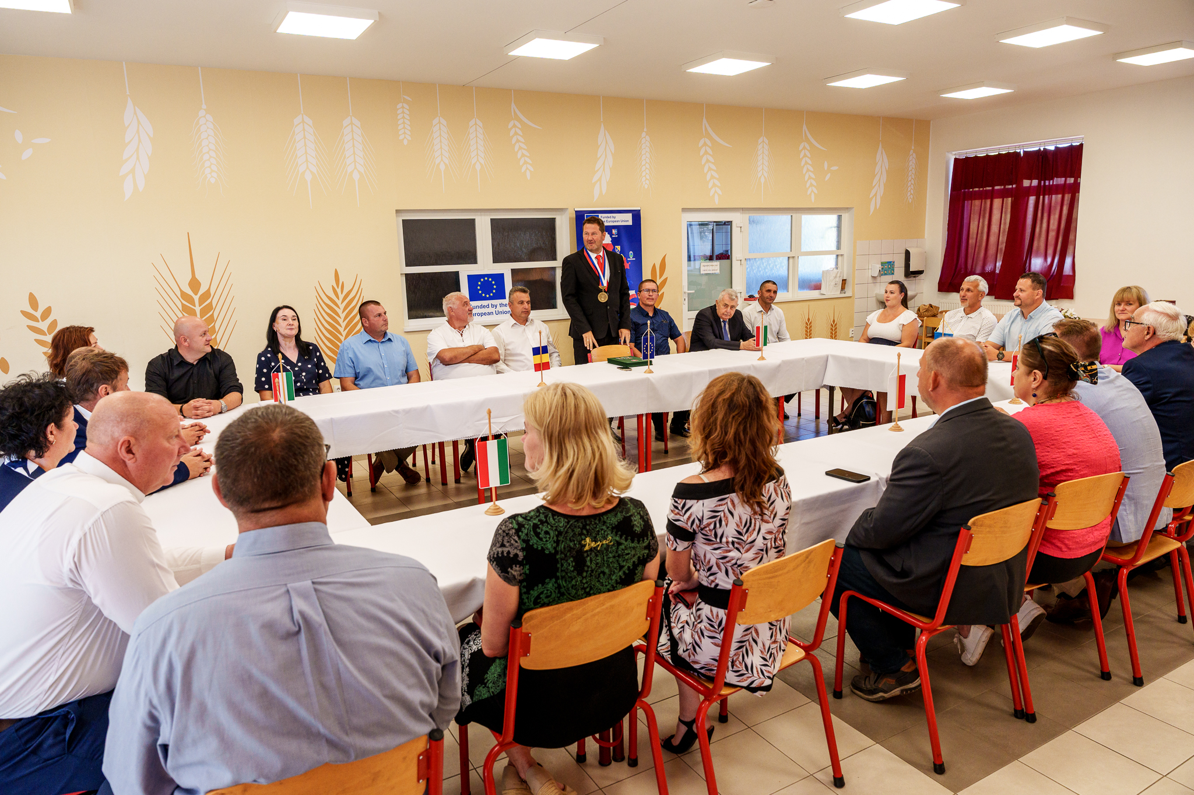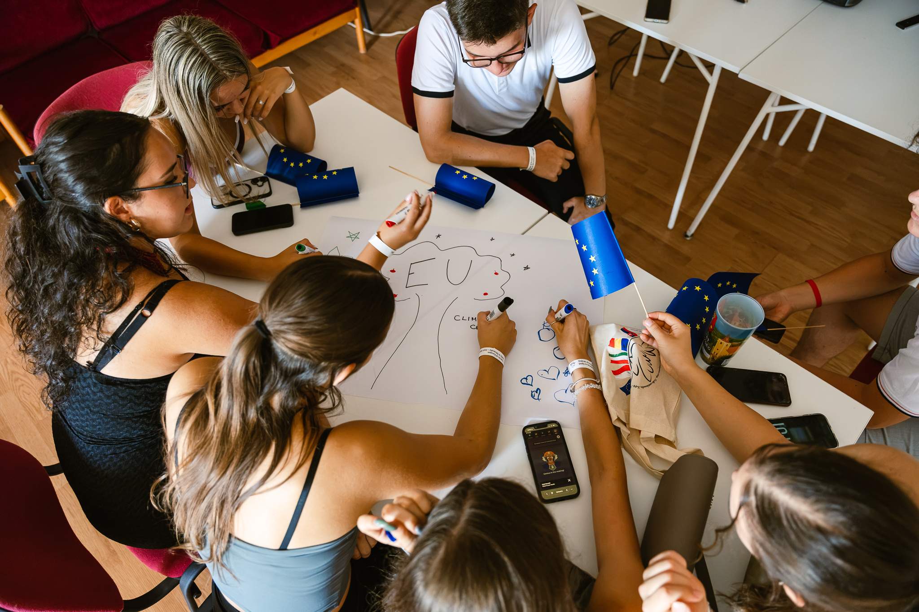
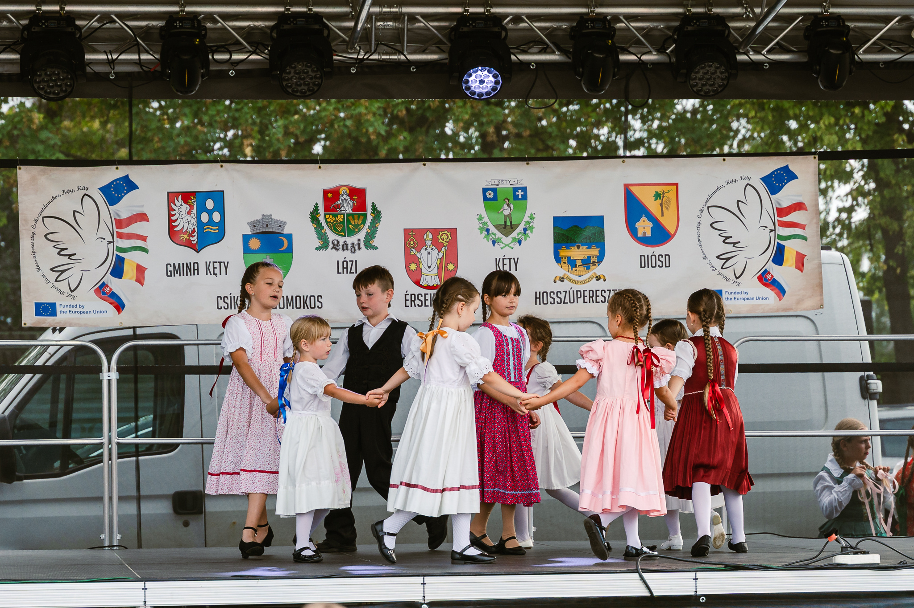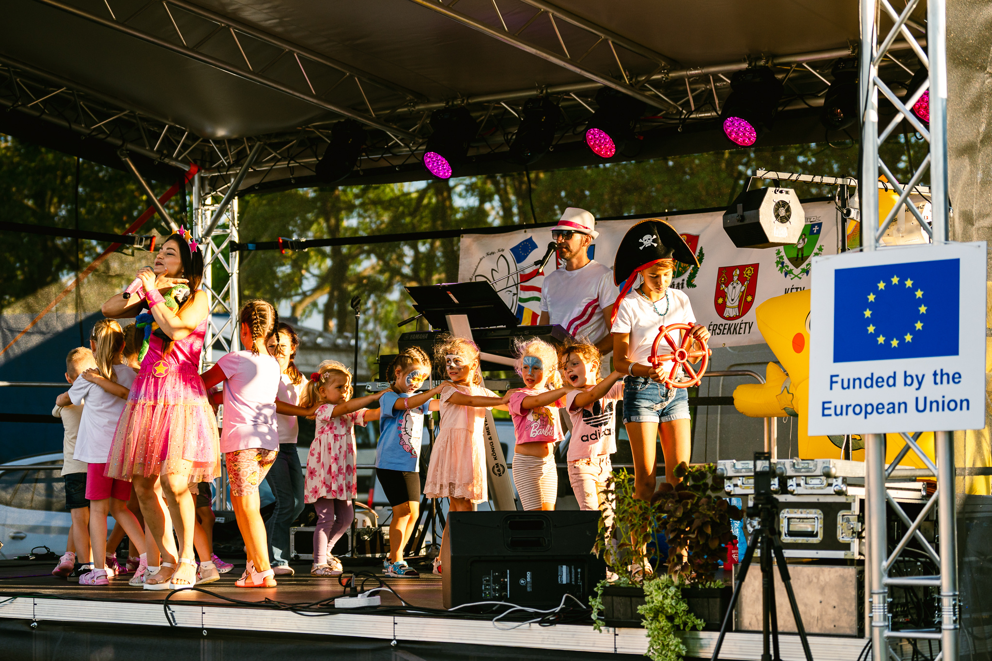
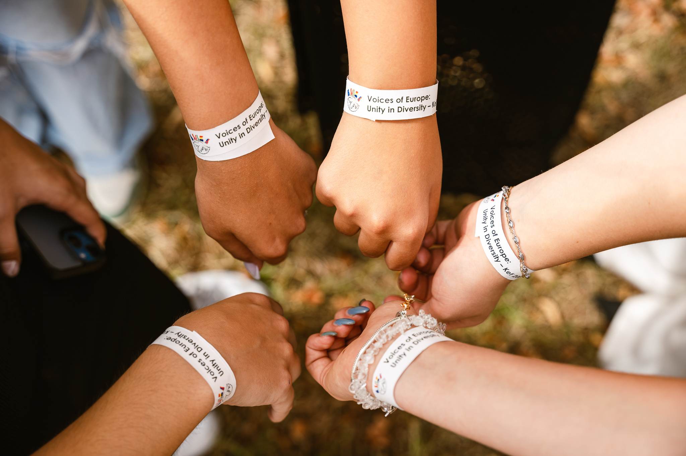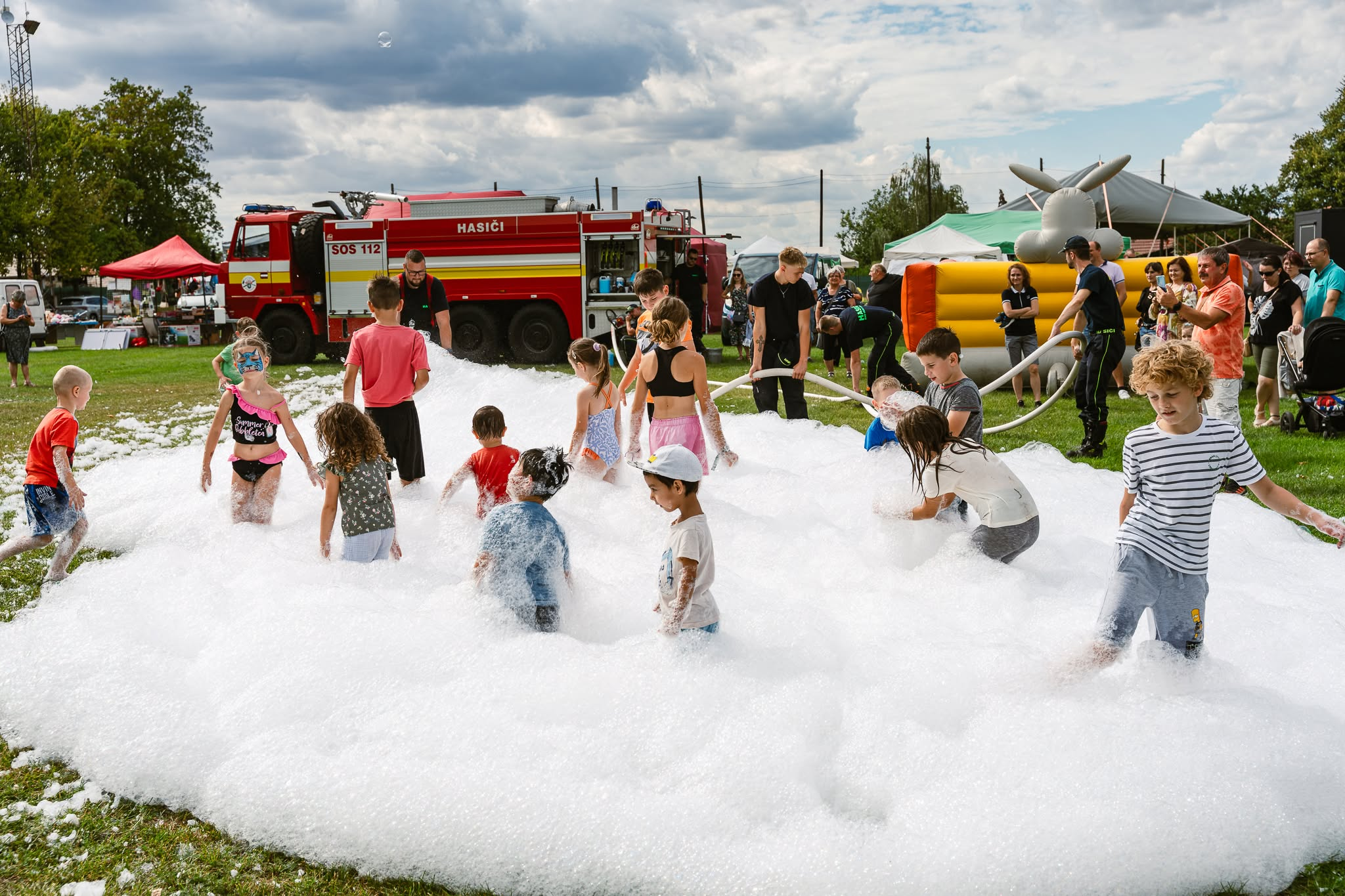

HISTORY OF CHANGES
VERSION | PUBLICATION DATE | CHANGE
1.0 | 01.04.2022 | Initial version (new MFF).

